Cryptid Hunter User Manual

Brookes Courts

Software Development 140

Instructor Julie King

December 11, 2023



"In the heart of mysterious wilderness, meet Yukon Jack, an intrepid explorer with a passion for the unknown. Known far and wide as the Cryptid Hunter, Yukon Jack seeks to unravel the secrets of legendary creatures that have eluded the lens of cameras for years. As players embark on the Cryptid Hunter adventure, they step into Yukon Jack's boots, navigating treacherous landscapes and facing the unpredictable. From the scorching deserts in search of the elusive Chupacabra to the towering mountains, where the Moth Man is said to soar, and deep into the haunting forests where the Wendigo lurks, each mission brings unique challenges and thrilling encounters. The choices made by players shape Yukon Jack's fate as he endeavors to capture these mythical beings on film and unveil the mysteries of the Cryptid world."

Playing the Cryptid Hunter game is simple. All that is required is a python installation, installation of both tkinter and PIL, and a mouse.

A mouse is used for navigation through the game. Simply click on the game prompts until you get to a decision point. When you get to a decision point, read carefully, and choose Yukon Jack’s action.

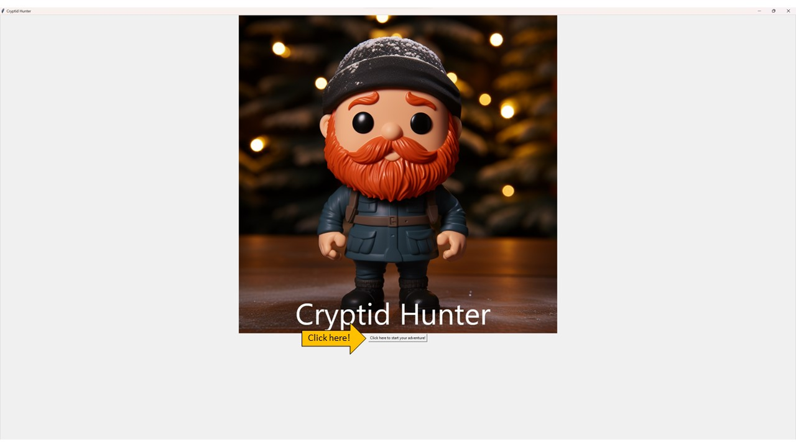

Title Screen

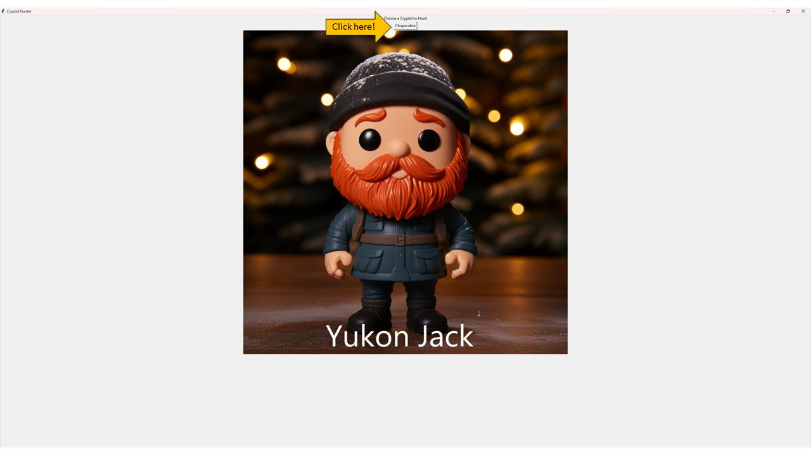

Mission Selection

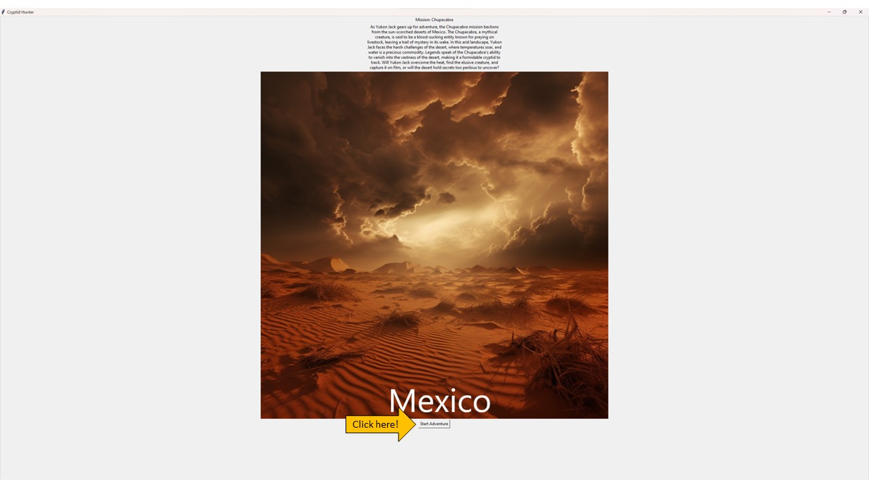

Mission Information

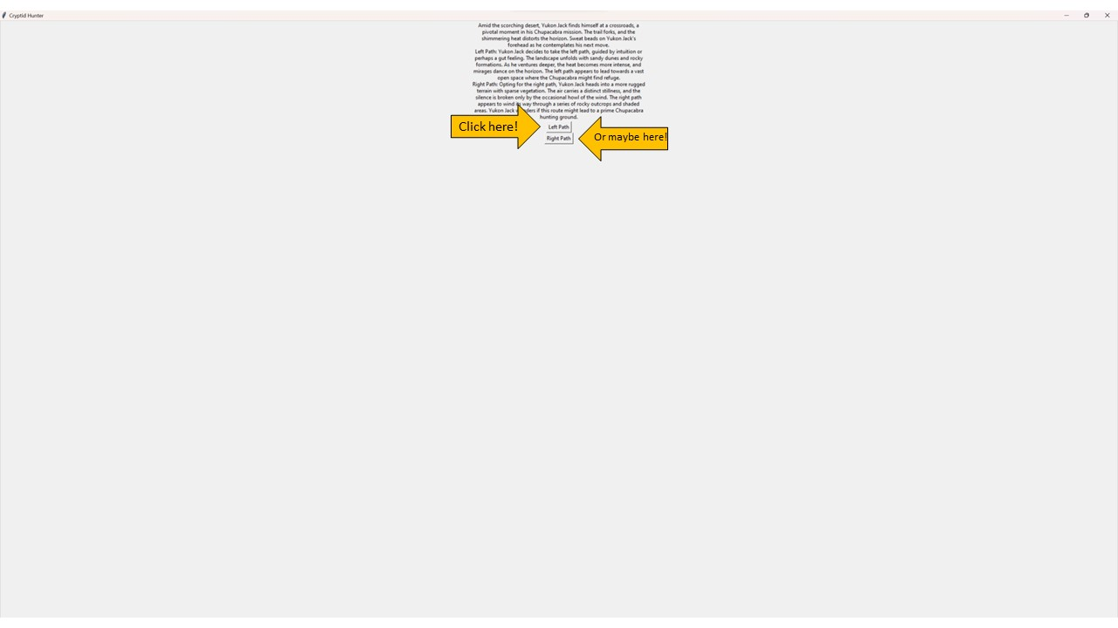

Decision Point

Will Yukon Jack photograph the cryptid or meet his fate? Simply click his action and find out!